**Ho Chi Minh City Open University**

**Graduate School**

97 Vo Van Tan, Dist.3, HCMC, Vietnam

**ASSIGNMENT COVER SHEET AND REPORT**

**MASTER in TESOL – CLASS: MTESOL017A**

|  |
| --- |
| **Name of candidate:** PHAN THỊ THUỲ TRÂM |
| **Student No:** 178 1401110036 |
| **Email address:** tramptt.178t@ou.edu.vn |
| **Name of coursework subject:**  INSTRUCTIONAL TECHNOLOGY |
|  |
| **Title of this item of work:**  FINAL PROJECT REPORT |
| **Name of lecturer:** Dr. NGUYEN NGOC VU |
| **Due date: 30 Nov 2018** |

**STATEMENT OF AUTHORSHIP:**

I certify that the above assignment is my original work; it is based on my own research. All sources used by me have been documented. No other person’s work has been used without due acknowledgement. This piece of work has not previously been submitted for assessment in this or any other subject or course at this University or elsewhere.

Student’s Signature…………..……………………………… Date………………………...

FINAL WEBQUEST PROJECT REPORT

Website Link:

<https://tramptt178t.wixsite.com/home>

Instructor: Dr. Nguyen Ngoc Vu

Student: Phan Thi Thuy Tram

2018

**Table of Contents**

INTRODUCTION 3

1. WebQuest and the other tools for website building in the course 3
2. The accomplishment of my WebQuest project 6

2.1. Preparation 6

2.2. Process 9

2.3. The implementation of WebQuest in English Language Teaching and Learning 13

CONCLUSION 14

**References 15**

**Appendices 16**

**INTRODUCTION**

The Internet of Things has entered in almost all areas in the world, especially education. Portable devices like laptop, mobile phone and the free available 24/7 Wi-Fi seem to become something obviously existing in people life. In terms of language education, modern classrooms are gradually defined towards the perspective of ‘ubiquitous learning’ that is language learning should be designed in away that can support learning everywhere, in the students’ self paces and personalizing students’ needs. New requirements for every lesson conclude not just only knowledge teaching but also skills and additional values. High level of thinking like, problem solving, evaluation, critical thinking are some examples. As an evitable result, the Information and Communication Technology (ICT) tools and electronic devices are introduced into the classroom as a means of need to facilitate and color the learning activities.

It is a fact that the implementation of ICT tools in classroom still remains certain hesitations by some teachers and educators. The concerns pose especially on the use of electronic devices for the e-learning, for fear of losing control in the activities as well as causing students’ distractions. However, e-learning with the e-activities have proved their benefits in many ways. In particular, some websites or mobile applications can provide online quizzes, interactive communications, collaborative group work, quick-accessed resource that teachers can design faster and more convenient compared to the traditional lessons. WebQuest is a case in point. This website allows a type of project-based learning in which all the activities and instruction are constructed under a website platform.

In this paper, I will firstly draw on the WebQuest project as a tool of learning, together with the other tools introduced in this Instructional Technology course. This will be followed by a description on how I prepare and process the WebQuest project. Finally, I would like to express my own thoughts on the implementation of the tools in a language classroom as a teacher, and, most importantly, what I learned after completing the project as a learner.

1. **WebQuest and the other tools for website building in the course**

**First tools for creating a website**

In this course, I have been challenged with different types of ICT tools like software and websites in the way how to use and apply them in teaching activities. Among the tools, building website is one of my most favourite parts. The main contents for website building was just covered in several weeks with basic concepts like HTML and tools like Notepad, Dreamweaver and the site [www.000webhost.com](http://www.000webhost.com). For the graphic designing part, I also had chance to practice the with the websites [www.canva.com](http://www.canva.com) and [www.crello.com/home](http://www.crello.com/home) . I personally found all the tools are useful and interesting, especially during time I was working with my final project WebQuest.

First of all, the HTML code and the hand-on practice writing code on Notepad are really interesting and encouraging my further learning. I used to try learning HTML and Java code with some my friends. Unofficially and randomly picking up anything my friends tell, I guess I feel quite vague all about them. My friends also advised me a link for self learning the codes [www.w3schools.com](http://www.w3schools.com) but it seems not really helpful to me. After writing code myself on the Notepad and the turn the page into a website form was really amazing. This help me understand the structure of the frame page clearer with the pairs of the opening-closed code of head, title, body and other elements. In order word, I have learned the traditional page design and basic elements (appendix A).

This was also the first encouraging step for me to explore other elements of the code. From this, I also can read and partly understand the source of some web pages and learn how people develop a website in different ways.

When it comes to the Dreamweaver, I have learned about the page structure and how to linked different pages together. Dreamweaver CSS6 version is a website creating program. With the help of the software, the codes become easier to read and use. Whenever I put something on the design window, the code appears parallelly on the code window. I have worked on a model website given by Dr. Vu and learned to identify the basic components and their positions at a page structure. For example, traditionally, the logo is at the left top corner. A banner is next, right below is the navigation bar. One more important notice is the index page, also the home page which will then be linked to the other subpages.

In terms of making the new banners or online posters, the website Canva offers me an easy way to create a nice banner my own without run the other graphic software like Photoshop or Illustrator. The Webhost is a host website provide user a free website domain. After upload the page source built by Dreamweaver, I can launch my website as an online link under the service of the Webhost. Thanks to this I have chance to familiarize with another concept ‘website domain’.

**My WebQuest project and other concerns for website designing**

All these above concepts and tools are my first step-in on how to build a website. However, I realized that creating an online page is not really difficult, but building a good and catchy website is truly not easy at all. Although all the elements and contents are prepared already, its cost me time and efforts to do the edition with the color, added new background, banner and some effects to complete the websites. My first website in this course is an example. The template and design are quite simple and looked old fashion. When we had a video conference and were introduced some other nice website models, I have noticed on the idea of what is a good website. This leads me to further reading on the internet, and I have learned new concepts: ‘flat design’. That is a modern trend of design, tending to maximize the user-friendly template and simplify the content and decoration. I have learned that an effective website template not only requires a clear information organization but also appropriate use of navigation menu, font style and size, colours, images and other elements.

But, first and utmost, the purpose of a website always is the initial issue to concern. This is because the reason for a website will affect not only how people construct the content but also design a suitable template for it. This time, I was assigned the WebQuest project, a website for learning activity. To prepare us for the project, Dr. Vu provided us a page of WebQuest community and many examples from the link [www.questgarden.com](http://www.questgarden.com). I have learned about the six main components: Introduction, Task, Process, Resources, Evaluation and Conclusion. To clarify the type of WebQuest, he asked us to explore about one concept ‘project-based learning’ and compare with ‘WebQuest’. To define the term clearer, I picked one definition from British Council page: it is a constructivist approach to learning in which the activities are oriented towards a specific goal. Students can access to the information via websites.

Compared to the project-based learning, WebQuest is not meant to generate any final product to solve a particular problem. It is used mainly to support students learning. The activities in WebQuest are designed to enhance students’ team-work skills, high level of thinking and utilizing the use of technology.

By the purpose for high level of thinking, I remembered Dr. Vu has noticed us on the three types of questions: essential, unit and content questions when building the content for WebQuest. That is, the students are not merely expected to address the information but have to analyze, evaluate the information and then create their own performance based on the information. Those steps are three highest stages of the Bloom’s Taxonomy of hierarchical models.

In order words, the website will be a tool to help students broaden knowledge, develop communicative skills and soft skills through collaborative working, and boost personal level of thinking.

However, for teacher, building a WebQuest is really a challenge. The difficulties expose in many different aspects. Constructing a quality content with clear instructions and designing an effective website template are only the first concerns. Teachers will have to face on such thing like having an appropriate topic, authentic task in meaningful context and finding out reliable resources. Once teacher sits for the project, all the elements should be well-prepared before setting off the website designing or everything would turn into a mess. Then, this will cost more time and efforts to adjust and fix the web. Therefore, it can be said that the preparation step is very important in order to produce a successful WebQuest. In my case, I have experienced many unexpected problems derived during the time of content building. The process of the website designing later then is another story.

1. **The accomplishment of my WebQuest project**

**2.1. Preparation**

To prepare for the WebQuest project, I divided the first-hand work into two parts: Content and website layout.

For the Content part, I followed three main steps: Rubric checking, topic finding, six-component building. Firstly, I have to check up again the **rubric** for WebQuest which help me set the quality standard for my web. I easy found them on the website Webquest.org. Then, I list out important points I should remember before start off the next step, especially the full of six parts: Introduction, task, process, resources, evaluation and conclusion.

Finding a **topic** and aim are my second step. This step is also one of the parts took a lot of my time and efforts. The topic and goals have to go hand in hand because they then will the ground to grow parts of task and process. What I have done is careful selecting and narrowing the topic to meet the learning goals. My first intention is about ‘saving the endanger species under the impacts of global warming”. I want to put some meaning context to the activities. Yet, the topic is too broad. And, I looked around for other samples on the Questgarden.com for more ideas. Best topic, I realized, is the type of a particular action for need. Finally, I picked the name “finding a mascot for the coral reefs”. The topic covered the main purpose of the activities: students will find an animal as a representative for the coral reefs.

There are also other factors I considered when choosing the topic. That is the learners’ interest and level of language proficiency. Topic about marine creatures should be suitable for high school students at intermediate level. The topic should also need to sound attractive and motivating to engage students into the activity. The aims of the web include: providing new knowledge, group work, communication skills and critical thinking.

In the third step, I started to firm the six components step by steps,

* In the introduction, I began with a situation of need, leading to a call of action. The situation is that a nature conservation organization cannot find out an animal to be the representative for the project. Then, I ask the students for help. A followed question was raised to drawing their thinking out of: What should they do? (If they accept that invitation of help).
* In the task session, I present briefly on what they are going to do to help them have a general picture about their work. I also put some more questions as further suggestions to help them generate the first ideas about the coral reefs and the animal they want.
* For the process part, I led the students gradually through ten steps, showing them how to prepare for their ideas outline, how to share work with role playing or to find the information and visual aids.
* To support students’ work, I provided them resources with links. These links are categorized into groups of information that related to the course of process instructions. In stead of using a strip of pictures, I would like to used one large picture of a coral reef where can display most typical creatures so that students can image how diverse the reef can be.
* To evaluate students’ work, I rewrite the rubric based on the grading standard for presentation by the Ushmm.org. Finally, I include two last pages are a conclusion and a little bit sharing about myself.

For the website layout part, I drew a draft for the structure frame. With the goals set that the website needs to be catchy, effective and friendly for students, I explored a number of sample template in order to gather ideas for the frame. Firstly, I consulted the ideas of the modern trend of flat design with the following characteristics: simple layout, white space, content less, eye-catch colors, easy-to-read fonts. At the same time, I also imagined what visual aids and how I would arrange the visual materials to support the content appropriately. This is one of the models I follow.

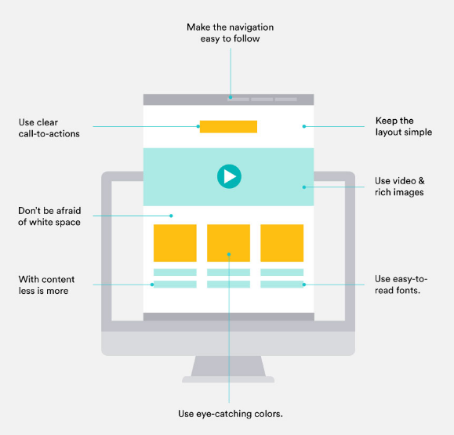

Flat template with engaging website design

<https://www.addthis.com/academy/how-to-create-engaging-website-design/>

However, I also want the students feel familiar with the layout. If the design is so straight, students may get confused or be distracted from the main content. This is the reasons why I decide to organize the navigation menu horizontally at the header right below the title like most common designs. The general structure of the page was still agreed with main part of a traditional page with enough header, footer and body in the middle. Then I started to sketch my draft with the components to see how the site will look like.

Other elements I also paid attention to are the color and fonts. In terms of colors, I chose the two main themes are blue sea and the orangish coral to fit with the topic about the coral reefs. The two colors also go well together to create contrast effects of the hot and cold spectrum. Regard to fonts, I choose the Basic and Helvetica. They are Serif font. Some websites advise that the Serif would be friendlier to readers and best applied for website.

The last part of my preparation is getting everything ready. I put all the content in a word file and materials in the image folder. The images are named and noted for which content. For the technical part, I employed Wix.com instead of Dreamweaver and the Webhost. Wix.com is a could-based platform for website development. It is ranked as in the top free website builder and ideal for novice developer practicing on website designing.

2.2. **Process**

First of all, I created an account on Wix.com with my email address. I started with a simple available template with already include header, body and footer. Then, it is time to have a look on my draft.

The first action of mine is put the title right on the middle of the header: “Finding a mascot for the coral reefs” and turned it in dark blue. Then I selected the type of horizontal menu, dragged it under the title, and divided intro eight sections like the below picture:

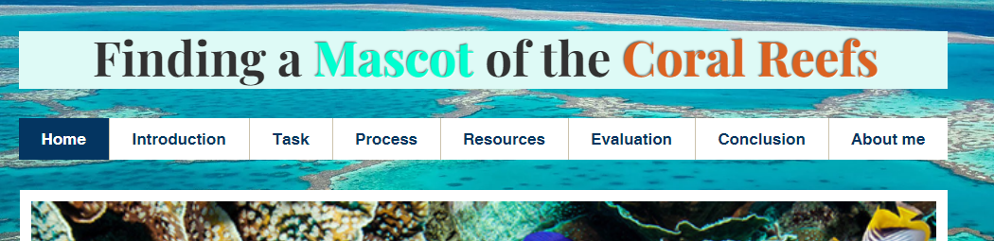

Next, I transfer the all the content from the word file form all the pages. Then, I went back to the Home page and set the background with the picture of the great coral reefs, with intention to complete the home page firstly. 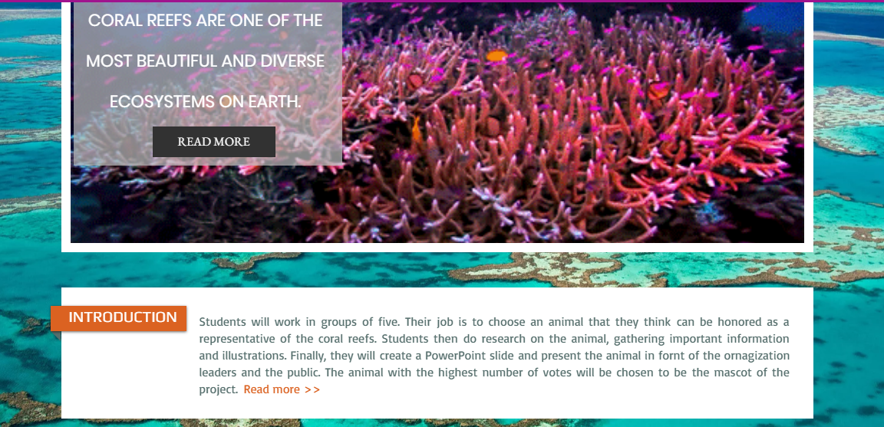

In the middle of the homepage, I depicted a slide strip of some colorful pictures to illustrate a closer look on the coral reefs and attract students’ attention on the topic. A brief of introduction is put right below the picture with the directed word ‘read more’ for a full content. The word ‘read more’ is linked to the page introduction.

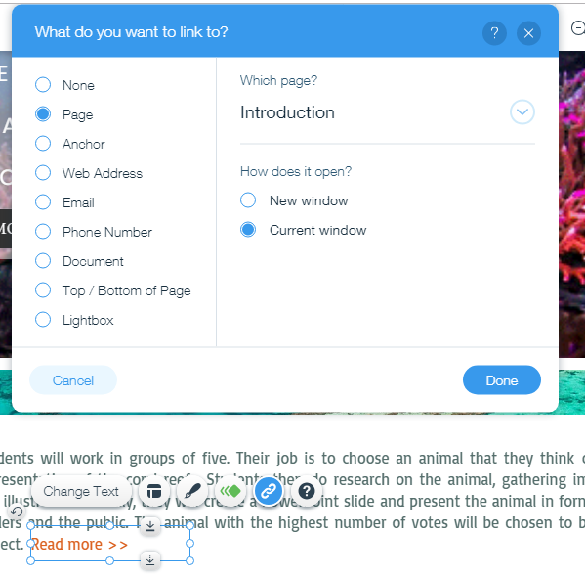

Similarly, the three main parts I wanted students to notice on are task, process and resources are set after the introduction. In this part, I learned the new concept ‘hover’ button. The hover is a twin of the regular side, but the hover area will have some changes when the mouse moves on. I linked the three hovers with the task page, process page and resource page respectively.

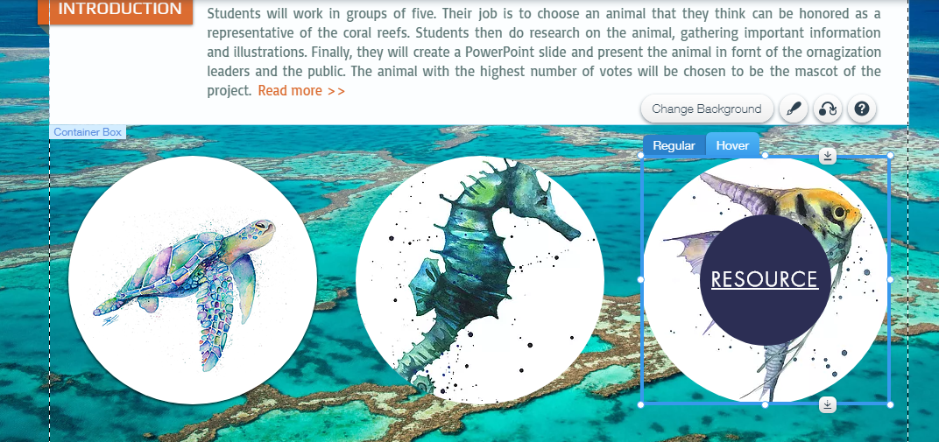

In the introduction page, I put in a new background to make the color tone darker, enhancing feelings of concentration. I also attacked an audio piece of music, with happy tropical melody. I hope the music can energize the students and get them ready to the next task.

Process page is one of the parts I put more efforts on. For fear that a long list of requirements may make the students get bored and step down from the activity. I tried to present them clearly, separately in parts and adjusted some moving effects on the icons next by.

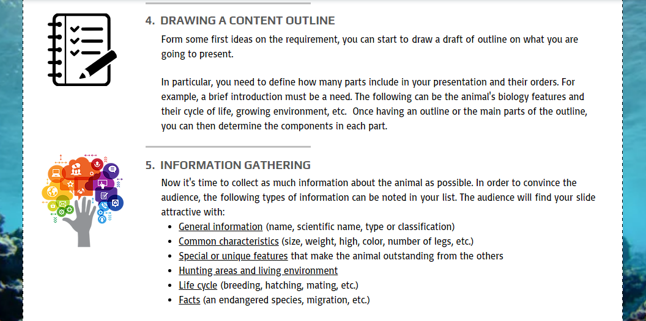

To indicate the colorful world of the coral reefs and the habitat diversity, I put I large picture of the coral and different marine creatures surrounding. The effects on this site also allowed me to write some note such as the name of animal on the picture. This partly can help provide some ideas for students about the ecosystem and how all the animals living together in the reefs. This illustration was set for the hover to create the moving effect of the line

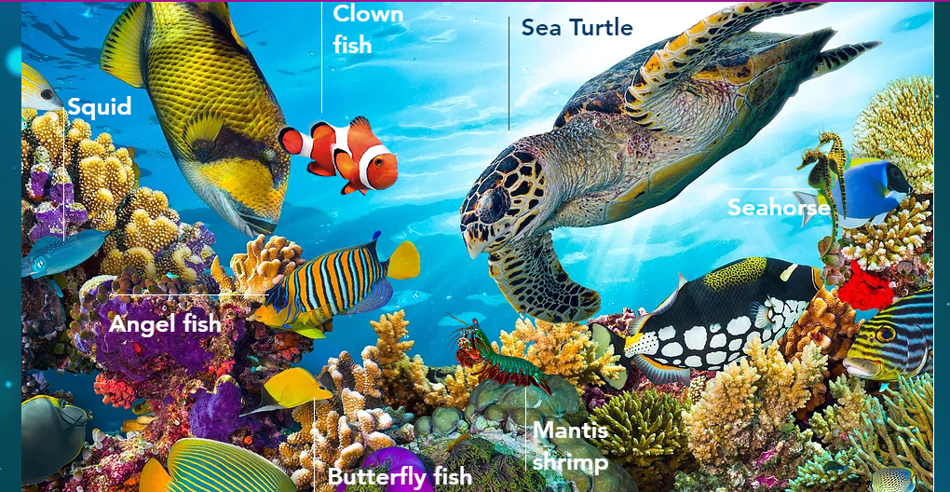

In this page, number of links for references were aligned with the key words. Besides, I enclosed a Youtube video about 15 most colorful animals to help students make their choice on the mascot. The last pages, evaluation, conclusion and teacher introduction mostly covered the main contain with very few visual aids.

In brief, thanks to the website building platform of Wix.com, I can create the desirable website layout. The Wix platform offers different choices on all the elements like banner, menu, button, box, strips of picture, motion effects, and so forth. For a novice developer, such website building platform like Wix allows me to cross my own limitation of the HTML code knowledge. When reading the page source of my Wix web, I find out many new codes. From my own feeling, creating website with Wix is very interesting and motivating. This is a part of the code from the my page source.

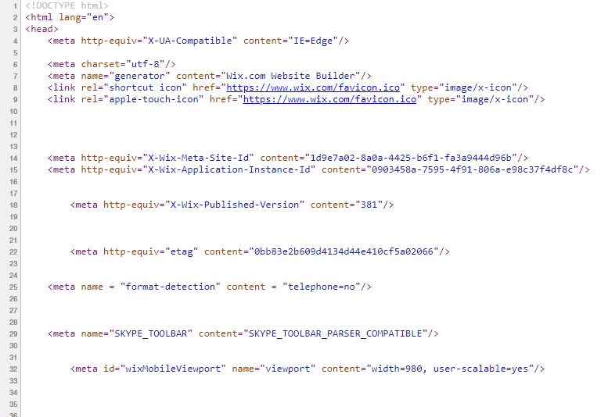

2.3. **The implementation of WebQuest in English Language Teaching and Learning**

WebQuest has been widely used in classroom to teach English native students the content knowledge of different subjects at school from physics, history to life sciences like biology. The implementation of WebQuest have proved to bring a number of benefits for students. Students are not only learned about the new knowledge but also develop other skills and gain additional values. Problem-solving, creativity, evaluation, group work, learning autonomy are some examples. Lessons with vivid digital materials like pictures, video, audio is also more appealing and motivating.

In English learning and teaching, the WebQuest can be employed in the content-based approach for achieving both subject matter and language knowledge. For example, teacher can teach English through a biology lesson. My website is also a case in point, teaching about marine life with English for Vietnamese students. By studying English with WebQuest, students can also improve their level of English proficiency. The WebQuest task will allow the four skills carried out interestedly and appropriately in real world situation to win a real task. As a result, students can be motivated and engaged to the learning activity.

For learners studying English as a second language, beside the above advantages, there are other noticeable benefits can be listed out like Renau and Pesudo (2016) indicated: “digital competence” and “cultural competence”. In order words, through WebQuest, students have opportunities to expose themselves in the digital world as well as new cultural contexts. They can increase their technology skills and pick up new cultural features presented in the reading materials given in the resources.

In terms of teaching, teachers are also gain much beneficial from the WebQuest. The improvement of tech skills and knowledge in some subjects are the most visible feature. One other striking point is the convenience for preparation, quick accessing and cost saving. It may take teacher a lot of time and efforts at the beginning. Once the teacher knows how to do and have an already-made template, he or she can quickly develop the new topic and new activities, easily sharing to students all the free resource from the internet.

However, there are also some limitations for the use of WebQuest should be concerned when using for English learning and teaching. The two first things are the limitation of school facilities (e.g. no Wi Fi connection) and the teachers’ tech skills. The next one is the subject matter. It is hard to find a suitable science subject to teach English, let alone creating the website task for the lesson. The final is students’ level of language proficiency. To achieve this type of learning, students need to be from pre-intermediate level and above.

CONCLUSION

Building the WebQuest is a useful and practical experience for teacher in general and for me in particular. WebQuest is one of many internet-based tools that will be gradually employed in the modern classroom for may outstanding advantages. The tool can bring benefits to both students and learners, preparing them necessary skills in this 4.0 age. The use of WebQuest can not only apply in teaching knowledge but also pro language practice. Teachers who has accomplishing the WebQuest project and understand the basis knowledge of website, can apply the skills of website building for other purposes like creating online portfolio.

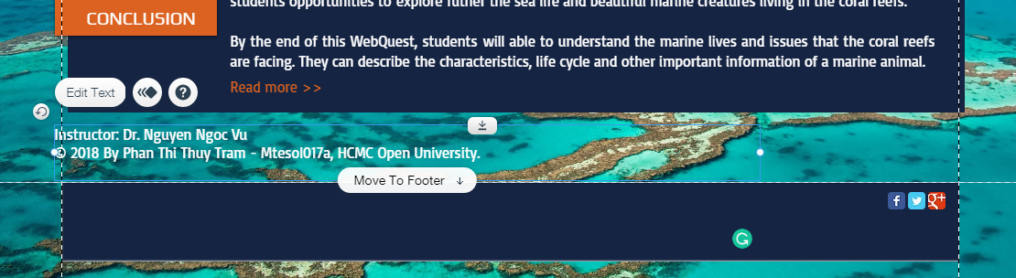Personally, I have learned many new skills and knowledge during the course and the WebQuest projects, not just the HTML code and Dreamweaver. The plat design is an example. After this project, I understand better how a good website should be in a way of engaging audience and user-friendly. This project opened new areas for my exploration. For example, I figured out what is ‘Web responsive’- the web template can fit to smaller screen like smart phone. I also meet a lot of unexpected difficulties like new terms and rules defined by a host platform. One case is my trouble with the text “..by Phan Thi Thuy Tram…” which should be at the footer. I would stick forever. with it. I was struggling around 20 minutes until I figured out that small button ‘move to the footer’.

Another example is the mode “Show on All Pages” and “Pin to the screen”. I once somehow turned on the mode the content boxes in home page and the other page just like turning upside down. I was thought I lose my control and slightly felt panic in some seconds.

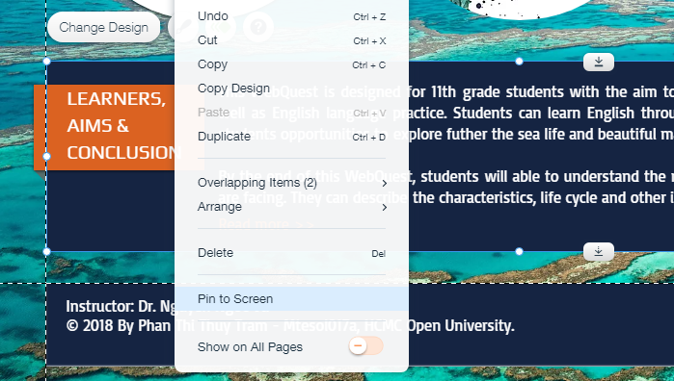

All in all, this WebQuest project is an amazing experience to me. I am inspired a lot when dealing with all the website elements. I am eager to have my hand on other web-based learning projects.

**References**

British Council, WebQuest definition. Retrieved from <https://www.teachingenglish.org.uk/article/webquests>

Renau, M. L., & Pesudo, M. (2016). Analysis of the implementation of a WebQuest for learning English in a secondary school in Spain. *International Journal of Education and Development using Information and Communication Technology*, *12*(2), 26-49.

Ushmm.org, Rubric for Grading Presentation. Retrieved from <https://www.ushmm.org/educators/lesson-plans/individual/teacher-commentary/teachers-rubric-for-grading-presentations>

**Appendices**

Appendix A

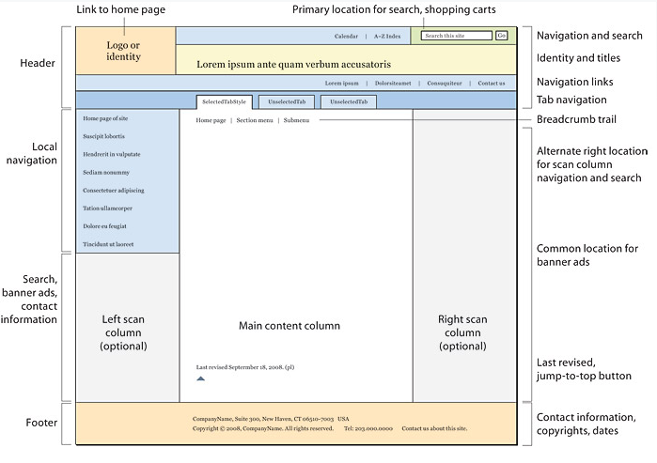

A traditional page design and major page elements

<https://webstyleguide.com/wsg3/6-page-structure/3-site-design.html>